PROJECT REPORT
Import Data using Transform Maps (Spreadsheet)
ServiceNow Project

Team ID | SWTID-2026-3373
Team Leader | Sivaperumal C
Team Members | Velmurugan G; Pradeep R; Sriram R; Selva Sri Ramani M
Platform | ServiceNow
Project Type | Micro Project – Import Sets and Transform Maps

1. INTRODUCTION

1.1 Project Overview
The project, “Import Data using Transform Maps (Spreadsheet),” demonstrates how structured employee data can be imported from an external Excel spreadsheet into the ServiceNow platform. The solution uses an Import Set table as a staging area and a Transform Map to map and transform the imported data into the Employee Test target table.
The project also demonstrates the use of Employee ID as a Coalesce field. This allows existing employee records to be identified during repeated imports and helps prevent unnecessary duplicate records. Reports and an Employee Analytics Dashboard provide visibility into the processed employee data.

1.2 Purpose
The purpose of the project is to provide a structured and reliable method for importing employee information into ServiceNow while reducing manual data entry, improving consistency, supporting repeated updates, and providing useful reporting and visualization.

2. IDEATION PHASE

2.1 Problem Statement
HR/Admin users need to manage employee information in a centralized system. Employee data is often received through spreadsheets and may need to be imported or updated repeatedly. Manual entry and repeated imports can be time-consuming and may result in duplicate or inconsistent employee records.
Therefore, a reliable ServiceNow-based import process is required to load spreadsheet data, transform it into structured employee records, identify existing employees, and provide clear visibility through reports.

2.2 Empathy Map Canvas
The target user is an HR/Admin user who manages employee records. The user's main concerns are accurate data entry, repeated spreadsheet imports, duplicate records, data consistency, and easy access to employee information.
- Says: “I need to import employee information quickly and accurately.”
- Thinks: “Repeated imports should not create duplicate employee records.”
- Does: Prepares spreadsheets, imports data, verifies records, and reviews reports.
- Feels: Concerned about manual effort, duplicate records, and inconsistent employee information.

2.3 Brainstorming
The main solution ideas considered were manual entry, spreadsheet-based record management, and a structured ServiceNow Import Set and Transform Map process. The selected idea was to use Import Sets and Transform Maps with Employee ID as the Coalesce field because it supports repeated imports, transformation, duplicate prevention, and reporting.
- Selected solution: ServiceNow Import Set + Transform Map + Coalesce.
- Target table: Employee Test.
- Staging table: Employee Import.
- Reports: Department, Location, and Employee List.
- Dashboard: Employee Analytics Dashboard.

3. REQUIREMENT ANALYSIS

3.1 Customer Journey Map
The HR/Admin user's journey begins with receiving employee information in an Excel spreadsheet, continues through loading and transforming the data in ServiceNow, and ends with verifying records and reviewing reports/dashboard information.
- Receive employee spreadsheet.
- Load employee data into the Employee Import staging table.
- Run the Sample Spreadsheet Import Transform Map.
- Use Employee ID Coalesce to identify existing records.
- Verify transformed records and Transform History.
- Review employee reports and dashboard.

3.2 Solution Requirement
The solution requires an Employee Test custom table containing Employee ID, Employee Name, Email, Department, and Location. An Employee Import staging table is required for spreadsheet data. A Transform Map named Sample Spreadsheet Import maps source fields to target fields. Employee ID is configured as Coalesce to support duplicate prevention and record updates. Reports and a dashboard provide visibility into employee data.

3.3 Data Flow Diagram
The main data flow is:
- Excel Spreadsheet → Employee Import (Import Set / staging table)
- Employee Import → Sample Spreadsheet Import (Transform Map)
- Transform Map → Employee Test (target table)
- Employee ID → Coalesce matching for existing records
- Employee Test → Reports → Employee Analytics Dashboard
[INSERT SCREENSHOT: Project Data Flow Diagram]

3.4 Technology Stack
Component | Technology | Purpose
User Interface | ServiceNow Web UI | Access project tables, imports, reports and dashboard.
Import Processing | ServiceNow Import Sets | Load spreadsheet data into the staging table.
Transformation | ServiceNow Transform Maps | Map and transform source data into target records.
Database | ServiceNow Database | Store Employee Test and import data.
File Source | Excel (.xlsx) | Provide employee spreadsheet data.
Security | ServiceNow ACLs / Access Controls | Restrict access to authorized users.
Infrastructure | ServiceNow Cloud Platform | Host the application and data.

4. PROJECT DESIGN

4.1 Problem Solution Fit
The solution directly addresses the main HR/Admin problems of manual data entry, repeated imports, duplicate employee records, and difficulty in viewing employee information. Import Sets provide a staging area, Transform Maps provide controlled field mapping and transformation, and Employee ID Coalesce helps update existing records instead of unnecessarily creating duplicates.

4.2 Proposed Solution
Develop a ServiceNow employee-data import workflow using an Employee Import staging table and a Sample Spreadsheet Import Transform Map. The source spreadsheet fields are mapped to the Employee Test target table. Employee ID is used as Coalesce to identify existing employee records. Reports and an Employee Analytics Dashboard provide centralized visibility into the resulting employee information.

4.3 Solution Architecture
Excel Spreadsheet → ServiceNow Web UI → Employee Import → Transform Map → Employee Test → Reports → Employee Analytics Dashboard.
[INSERT SCREENSHOT: Solution Architecture Diagram]

5. PROJECT PLANNING & SCHEDULING

5.1 Project Planning
The project was planned across two sprints using eight user stories and a total of 22 story points.
Sprint | User Stories | Story Points | Focus
Sprint-1 | USN-1, USN-2, USN-3, USN-4 | 11 | Employee table, import, Transform Map and transformation
Sprint-2 | USN-5, USN-6, USN-7, USN-8 | 11 | Coalesce, validation, reports and dashboard
Total Story Points: 22
Team Velocity: 22 / 2 = 11 Story Points per Sprint.

6. FUNCTIONAL AND PERFORMANCE TESTING

6.1 Performance Testing
Performance and functional verification focused on data loading, transformation, duplicate prevention, transform results, reports, and dashboard presentation.
Test Parameter | Result
Data Loading | Employee spreadsheet data was loaded into the Employee Import staging table.
Data Transformation | Sample Spreadsheet Import mapped Employee ID, Name, Email, Department and Location to the target fields.
Duplicate Prevention | Employee ID was configured as Coalesce.
Transform Results | Transform History was used to verify the completed transformation and processing statistics.
Report Design | Employees by Department, Employees by Location and Employee List Report were created.
Dashboard Design | Employee Analytics Dashboard was used to present the employee reports.

7. RESULTS

7.1 Output Screenshots
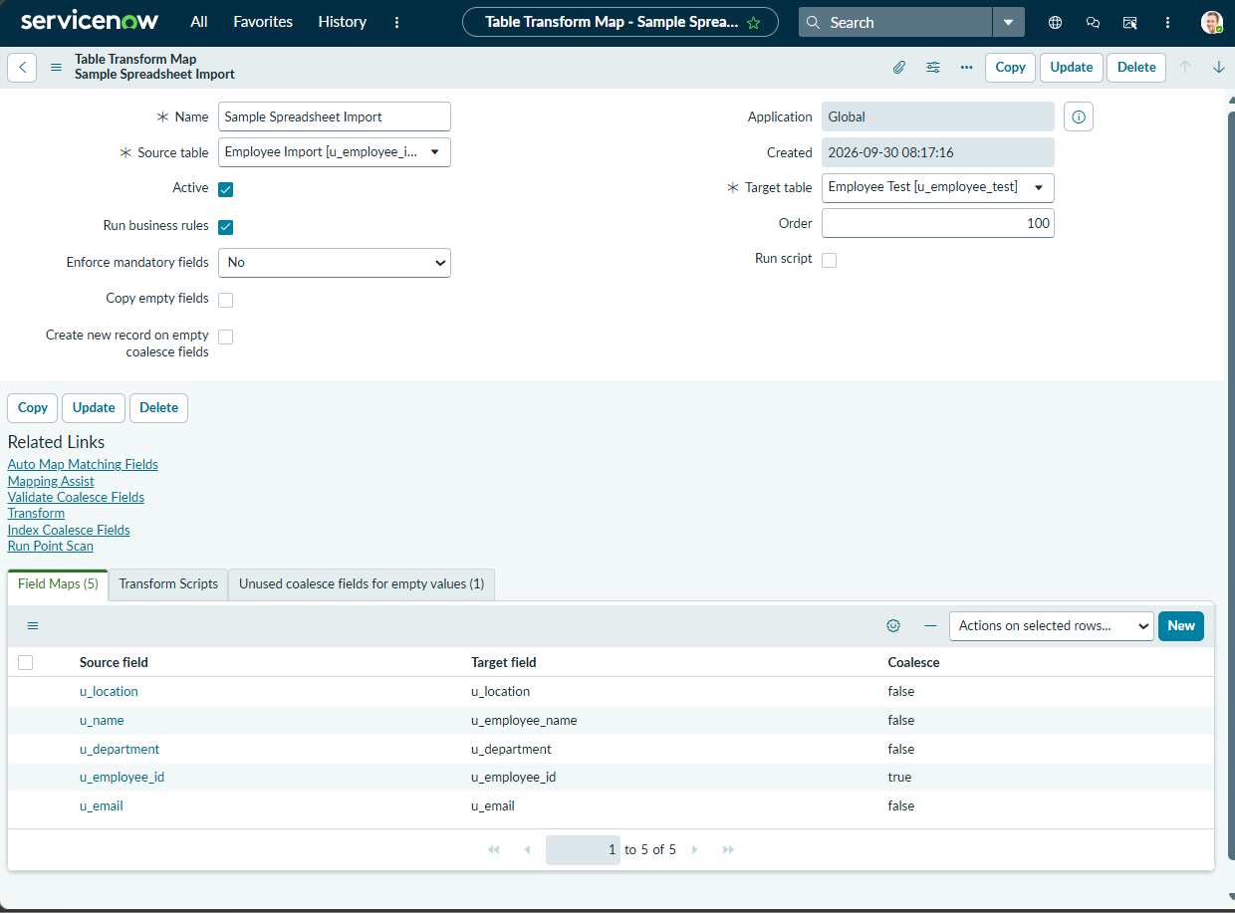
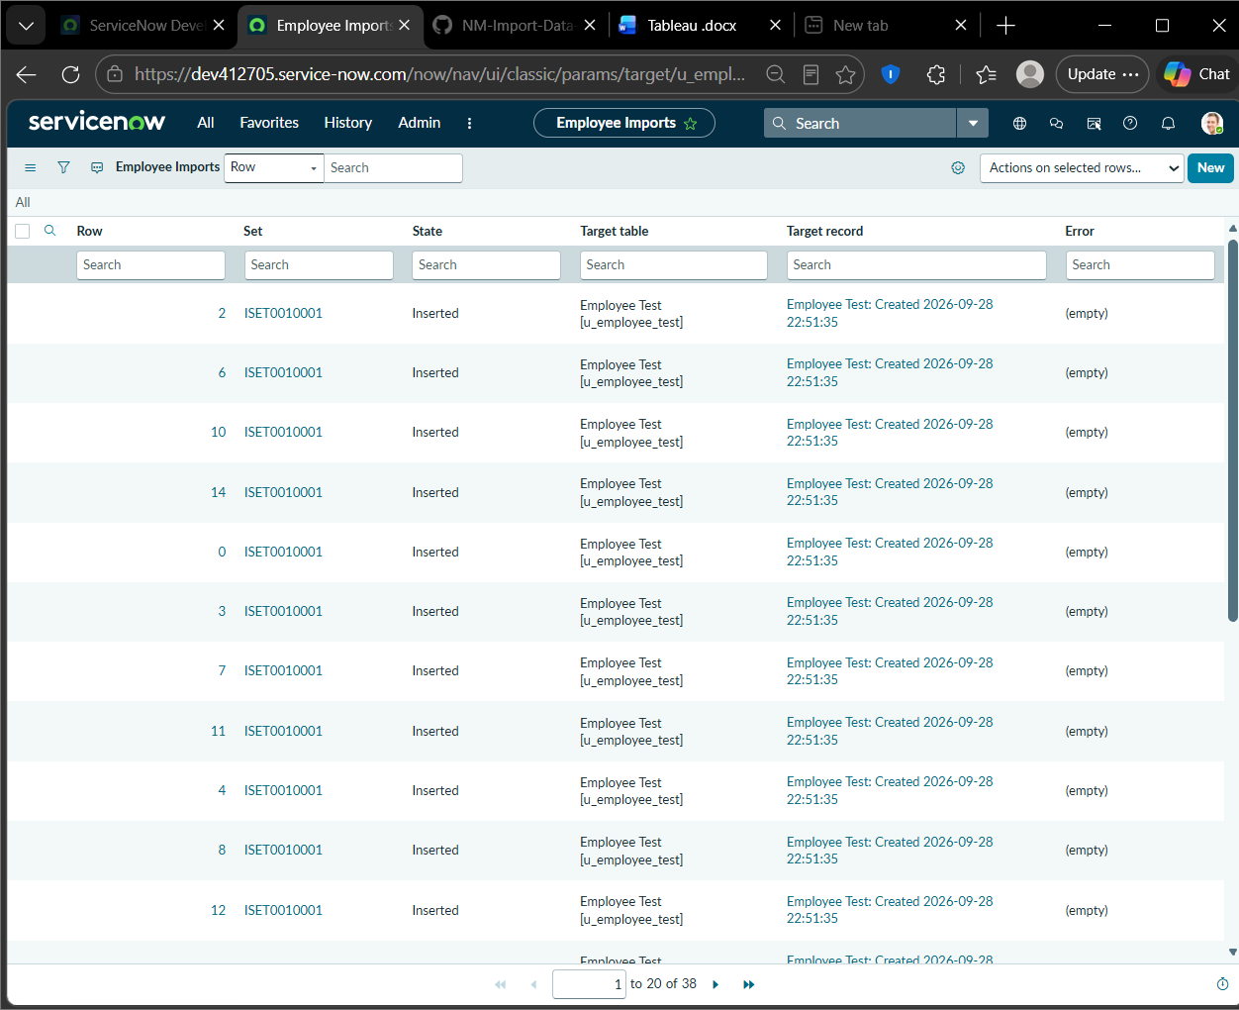

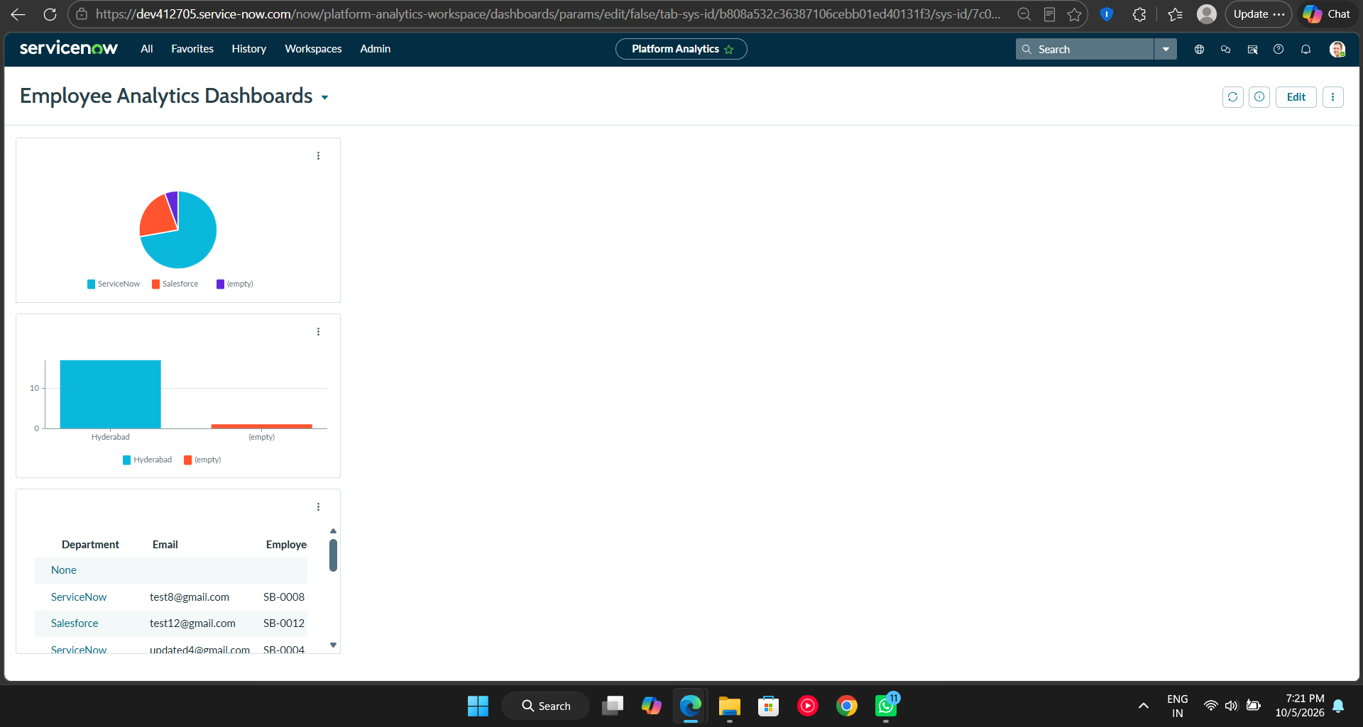
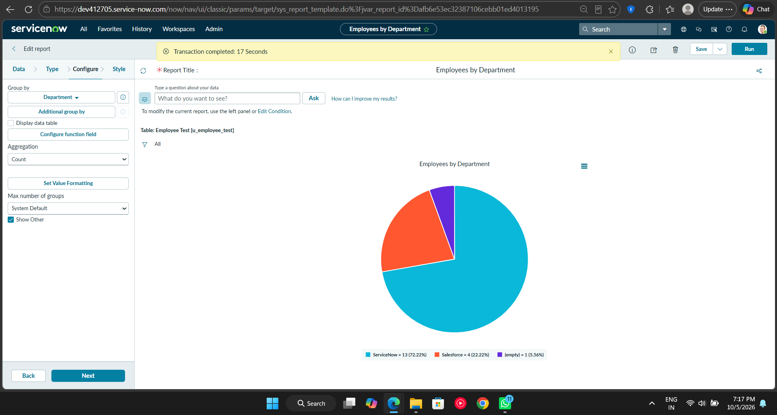
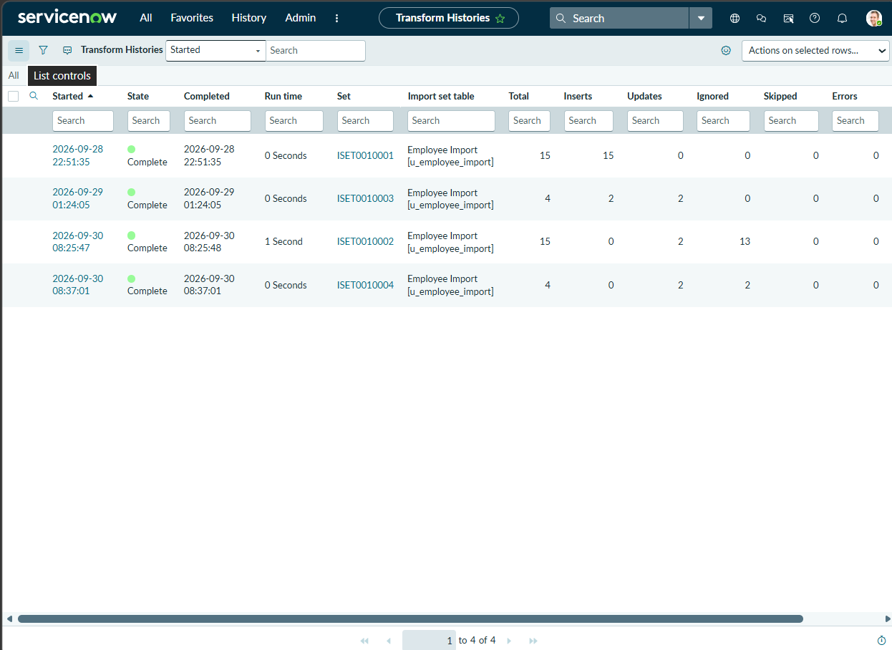
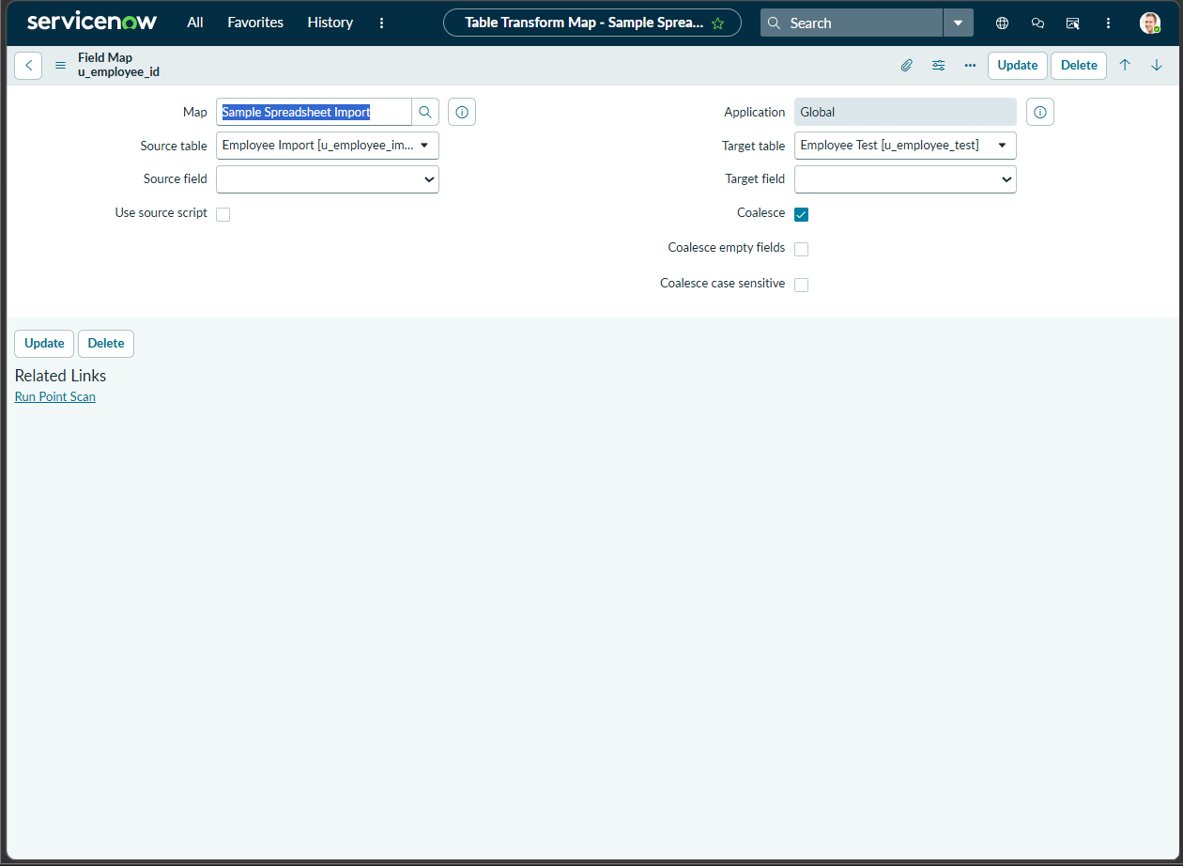

8. ADVANTAGES & DISADVANTAGES

Advantages
- Reduces manual employee data entry.
- Provides a structured spreadsheet-to-ServiceNow import workflow.
- Supports repeated imports and updates.
- Employee ID Coalesce helps prevent unnecessary duplicate records.
- Transform History provides visibility into import processing.
- Reports and dashboard make employee information easier to analyze.

Disadvantages
- The solution depends on correctly formatted spreadsheet data.
- Changes in spreadsheet column structure may require mapping changes.
- The current solution is designed for employee data and may require configuration for other datasets.
- It does not use external APIs or machine-learning models.

9. CONCLUSION
The project successfully demonstrates an employee data import solution using ServiceNow Import Sets and Transform Maps. Employee data is first loaded into the Employee Import staging table and then transformed into the Employee Test target table using the Sample Spreadsheet Import Transform Map.
Employee ID is configured as the Coalesce field so that repeated imports can identify existing employee records and support updates instead of unnecessary duplicate insertion. Transform History is used to verify transformation results. Reports and the Employee Analytics Dashboard provide a centralized view of the processed employee data.

10. FUTURE SCOPE
- Add additional employee fields and validation rules.
- Support more spreadsheet formats and larger datasets.
- Add automated scheduled imports from approved data sources.
- Add more reports and dashboard indicators for HR analysis.
- Introduce stronger data-quality validation for missing or invalid employee information.
- Extend the solution to other HR data import use cases.

